FINAL UPDATE: I have decided to not change anything in the draft, some timing for the animations are changed but other than that most things remain the same.

Also animations and their positions were designed in a 1920x1080 display monitor so use that for the best results, I cannot easily test other resolutions. I have included a video preview also to show what it looked like through my browser on my computer.

***Part 3 – Drafts***

**Demo 1 – Color**

Change font color.

Create an ***<input>*** element. Since this will be a color selector, we need to get it the type of “color” and give it an id (and name), so we can find it when we take the color value from it later.

***<input type=”color” id=”colorS”>***

Now to create an element of which we are going to modify, for the purposes of this demo, I will be using a ***<p>*** element. We can give it an ‘Id’ so we can reference in the JavaScript portion.

***<p id=”specialText”>***

To be able to change the CSS properties of the div, we will be using JavaScript.

In the function we need to; create a variable assign it to the ***<p>*** using it’s ‘Id’, create a variable that holds the color selectors value, and finally assign the color value to the ***color*** property of the ***<p>***.

**Demo 2 – Range**

Use range to change font size

**Demo 3 – Dropdown Box**

Demo will show how to change font style.

**Combination – Dropdown, Range, Color**

Not too sure yet.

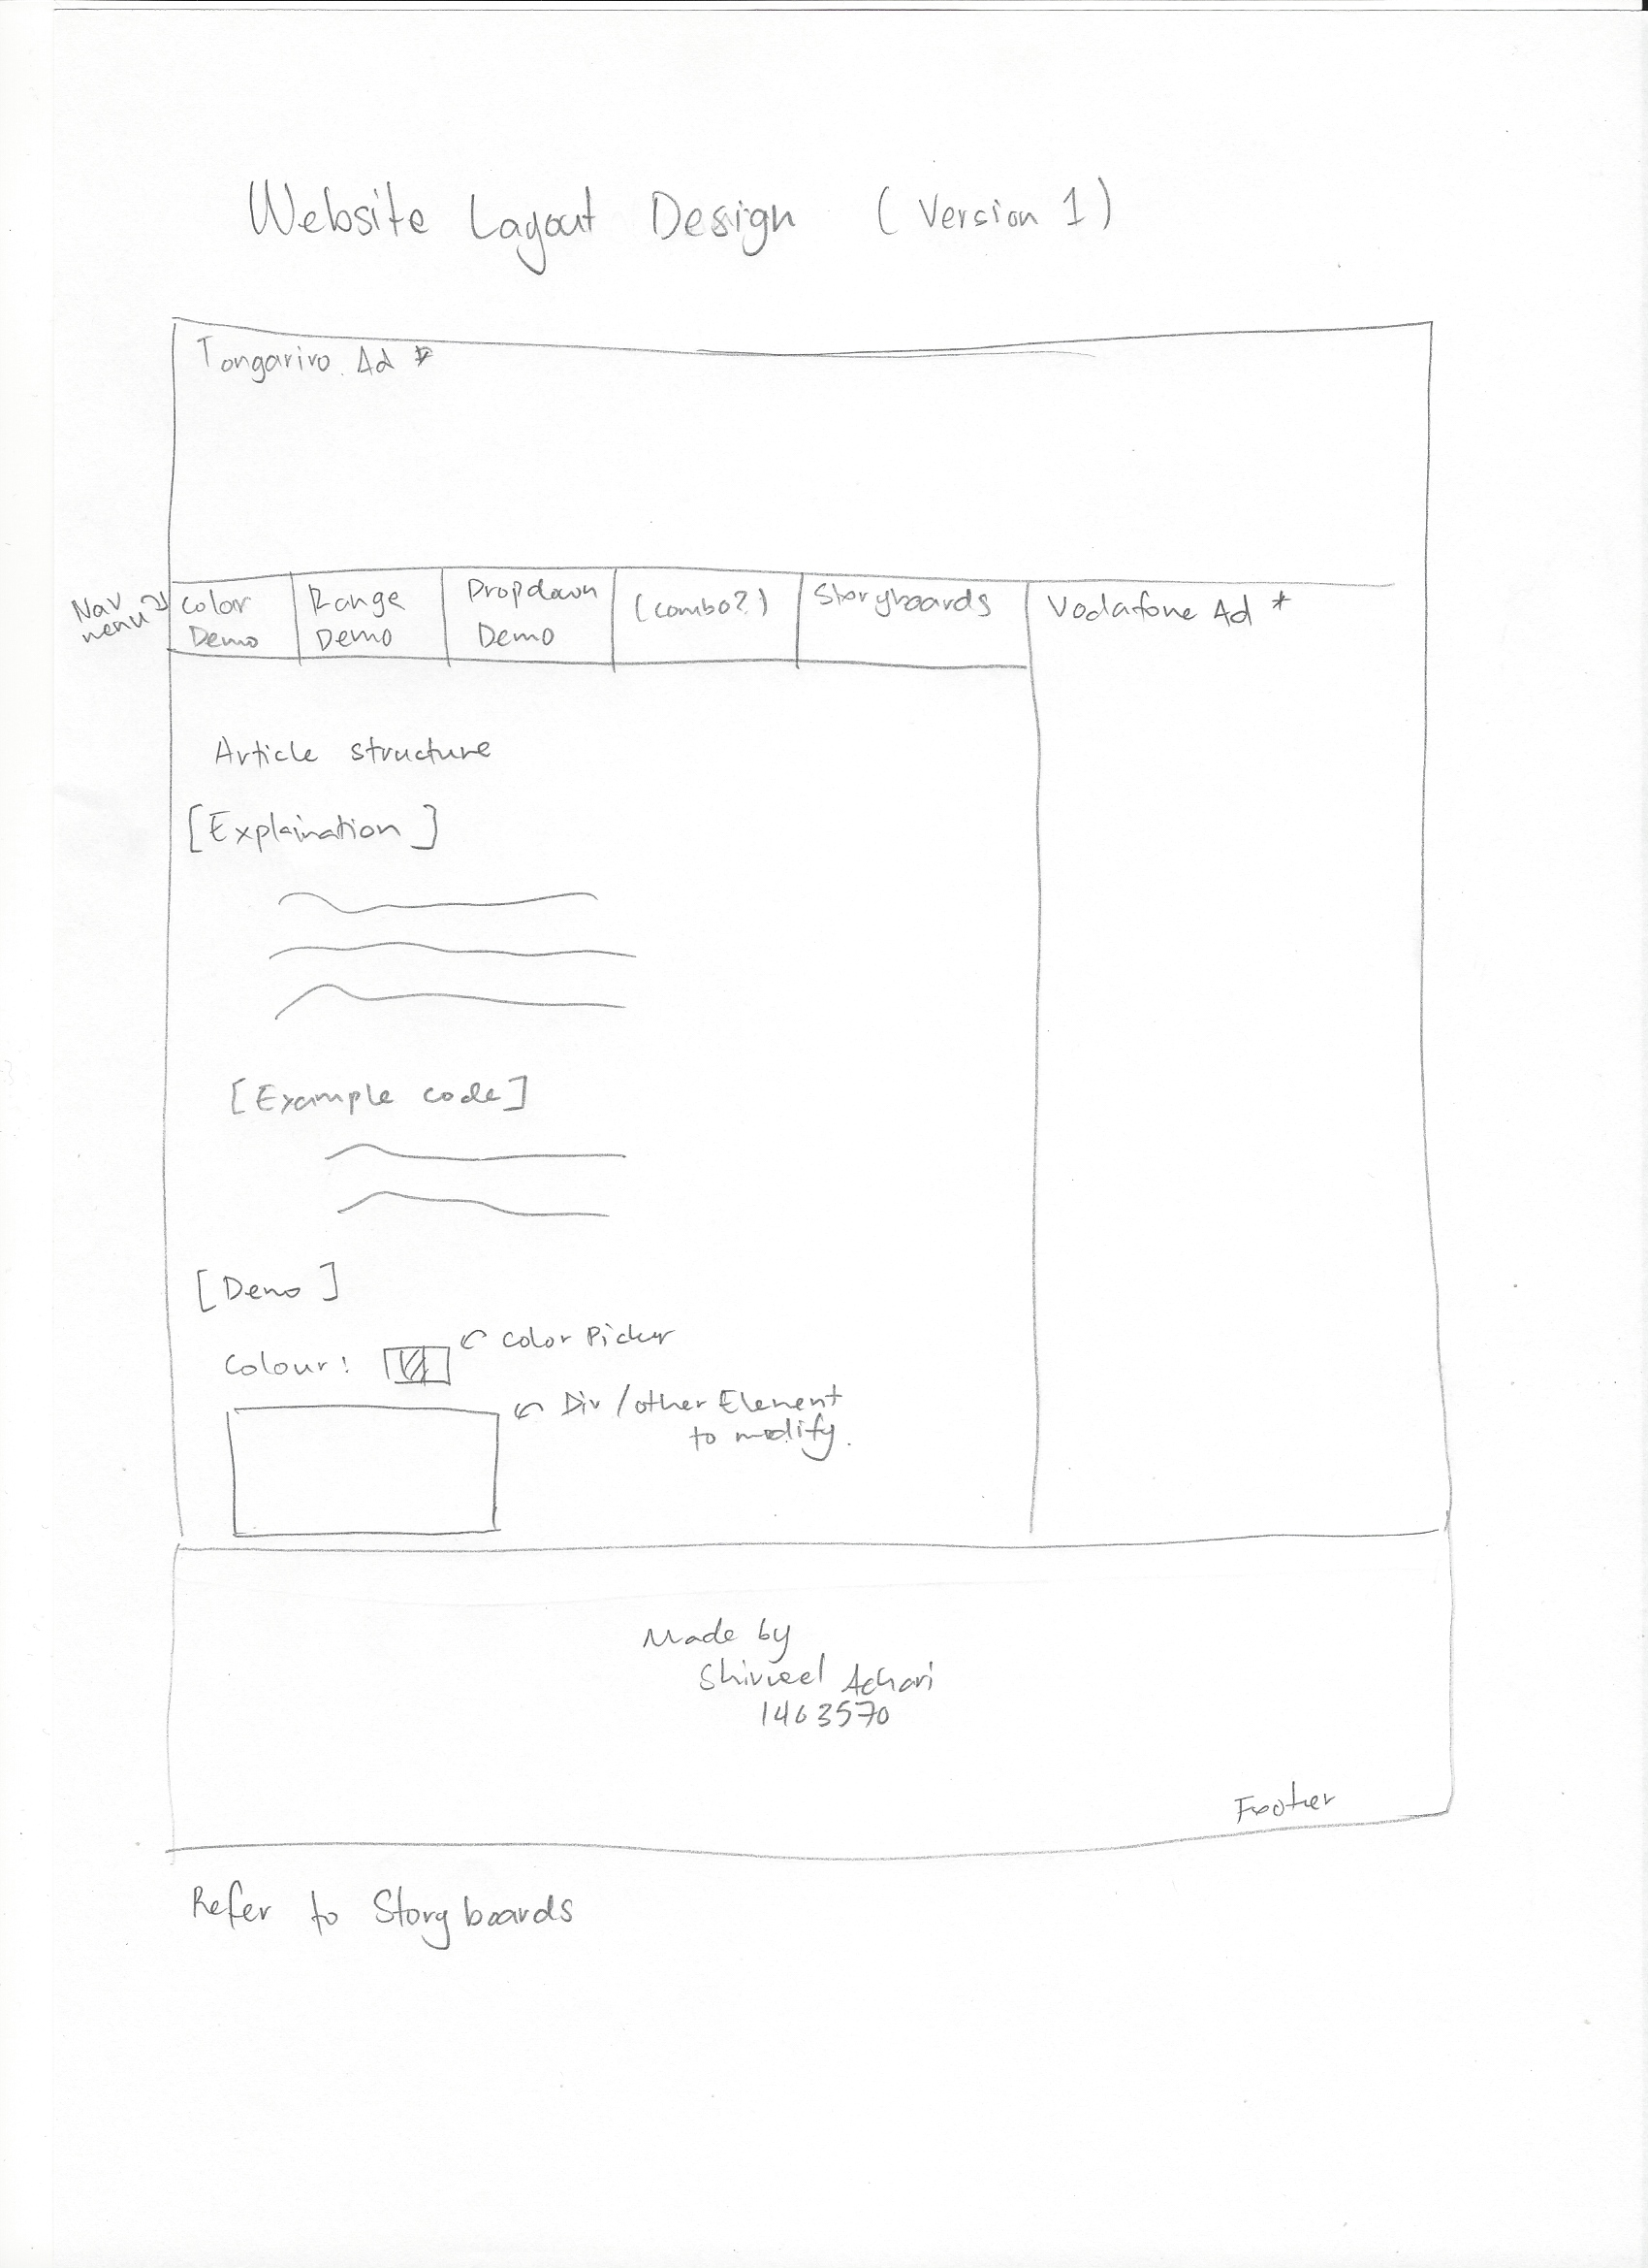Layout of Website